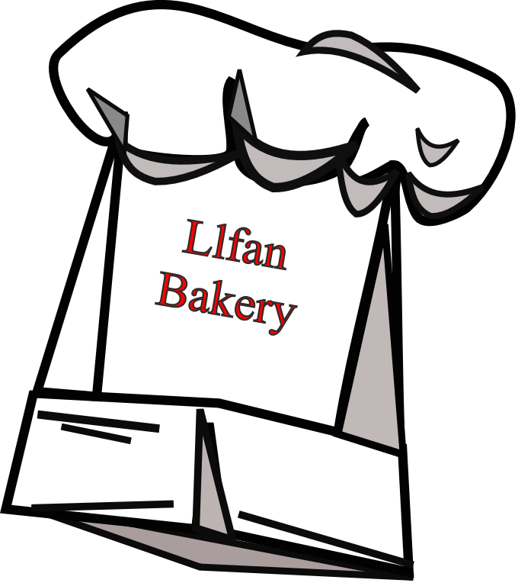
Llfan Bakery
Llfan Commercial Park
Welshpool SY21
+44 1632 960704

<Company_name>  <Address fields> | STATEMENT  Account ID <Account_id>  Contact: <Contact_Person or blank if Unknown>  Date: <date use d-MMM-yy format>

Dear <First name of Contact_Person or Customer if this is unknown>

Follow these rules to display the conditional text.
Letters to customers whose total for April is greater than £2000 and do not have
a Sum_Outstanding should include the following text:
As a customer whose monthly orders often total more than £2000, we are pleased to offer you a monthly account that you can use to order and pay for our products online.
Letters to customers who do have a Sum_Outstanding should include the following text:
Your orders in April amount to <Total for April> but unfortunately you have <Sum_Outstanding> still to pay. Please remit this amount as soon as possible. We reserve the right to refuse future orders.

Assuring you of our best intentions,
<add your name, centre number_candidate number here>

